Original Table: VACATIONTOUR (customer#, customerName, customerEmail, agent#, agentName, dateOfTour, tour#, tourDescription, tourRating, tourPrice)

Bringing to 1NF: VACATIONTOUR (customer#, tour#, dateOfTour, customerFirstName, customerLastName, customerEmail, agent#, agentName, tourDescription, tourRating, tourPrice)

Identify the functional dependencies:

(customer#) → (customerFirstName, customerLastName, customerEmail) (PD)

(agent#) → (agentFirstName, agentLastName) (TD)

(tour#) → (tourDescription) (PD)

(customer#, tour#, dateOfTour)->(customerFirstName, customerLastName, customerEmail, agent#, agentName, tourDescription, tourRating, tourPrice) (FD)

Bringing to 2NF:

Removing partial dependencies of tour# and customer# to get the 2NF table

VACATIONTOUR (customer#, tour#, dateOfTour, agent#, tourRating, tourDescription, tourPrice)

CUSTOMERS (customer#, customerFirstName, customerLastName, customerEmail)

TOUR (tour#, tourDesciption)

Bringing to 3NF:

Removing transitive dependency of agent# to get the 3NF table

VACATIONTOUR(customer#, tour#, dateOfTour,agent#, tourRating, tourPrice)

CUSTOMERS (customer#, customerFirstName, customerLastName, customerEmail)

AGENT (agent#, agentFirstName, agentLastName)

TOUR (tour#, tourDesciption)

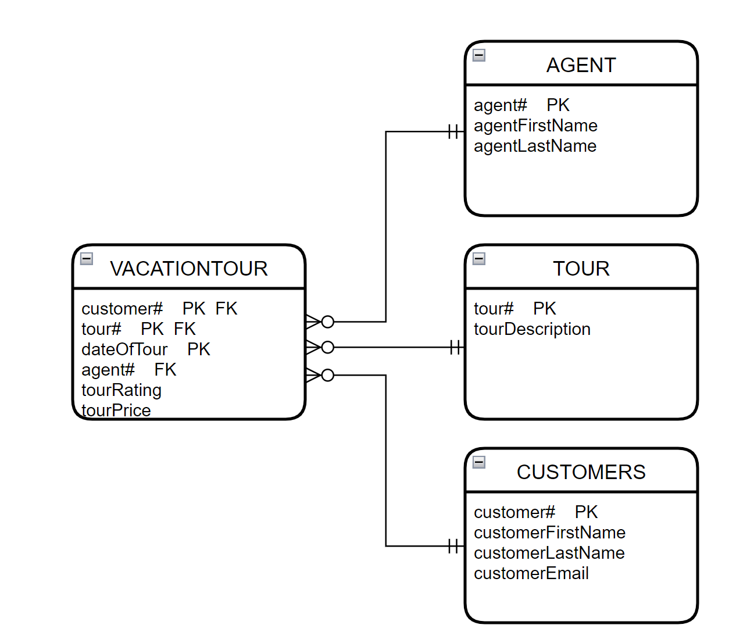

Attribution List

| **Activity** | **Date** | **Resources** | **Hours Spent** |
| --- | --- | --- | --- |
| Initial Group Meeting | Feb 9/2023 | D2L | 15 min |
| Bringing to 1NF | Feb 9/2023 | Scenerio/D2L/Tamara | 20 min |
| Identifying the full dependencies | Feb 9/2023 | Scenerio/D2L/Martin | 10 min |
| Bringing to 2NF: | Feb 9/2023 | Scenerio/D2L Jubril/JP | 30 min |
| Bringing to 3NF: | Feb 9/2023 | Scenerio/D2L/Jubril/JP | 5 min |
| Diagram Creation | Feb 10/2023 | All | 30 min |
| Attribution List Creation | Feb 10/2023 | JP | 10 min |
| Review | Feb 11/2023 | All | 20 min |
| Total Hrs |  |  | 2hrs 20min |